Talking really helps suicide prevention campaign
Please support the campaign through your own social media channels by creating your own posts or liking and sharing the social content posted from:
X: @publichealthni
Facebook: @publichealthagency
Instagram: @publichealthni
Please use the assets linked on the campaign resources page.
Campaign hashtags:
#TalkingReallyHelps
#Lifeline
#MentalHealth
Asset | Post copy
Talking really helps 30s video  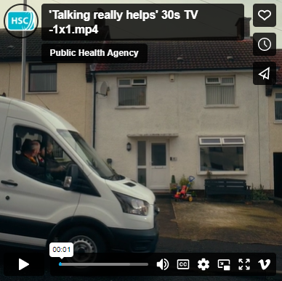 | If you are in distress or crisis, or you know someone who is, you can talk to one of Lifeline’s qualified counsellors for free, 24/7. Call Lifeline on 0808 808 8000.  Link:  Learn more at lifelinehelpline.info
Talking really helps 15s male video  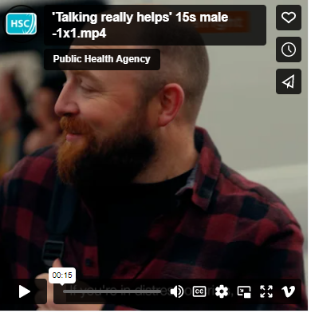 | Sometimes life can get on top of us. But that’s when talking matters most. Talk to one of Lifeline’s qualified counsellors for free, 24/7. Call Lifeline on 0808 808 8000.  Link:  Learn more at lifelinehelpline.info
Talking really helps 15s female video  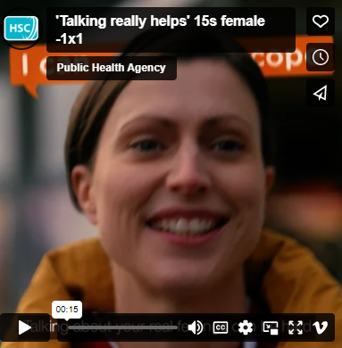 | When you are struggling to cope, it’s important to talk about it. Talk to a friend, family member of someone you trust. You can also call Lifeline and speak to a qualified counsellor for free, 24/7.  Link:  Call Lifeline on 0808 808 8000 or visit lifelinehelpline.info to learn more.
Lifeline counsellor video (calls)  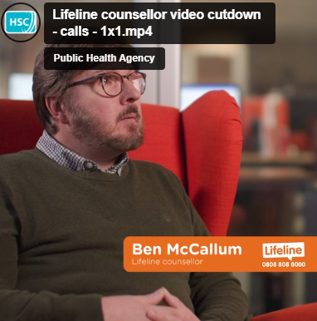 | If you’re struggling or feeling low, you can speak to one of Lifeline’s counsellors about anything that is troubling you, for free, 24/7.  Link:  Call Lifeline on 0808 808 8000 or visit lifelinehelpline.info to learn more.
Lifeline counsellor video (not a burden)  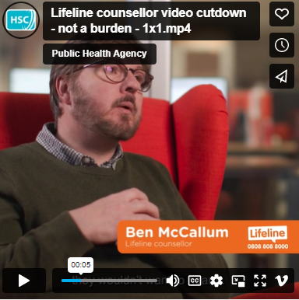 | Trained counsellors like Ben are able to provide immediate help and support to anyone in crisis or despair. If you’re struggling to cope, don’t suffer alone. Talk to Lifeline today.  Link:  Call Lifeline on 0808 808 8000 or visit lifelinehelpline.info to learn more.
Lifeline counsellor video (things can get better)  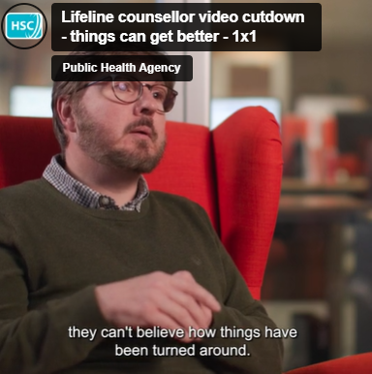 | When you’re struggling or feeling low, it’s important that you talk to someone. Because when you start talking, you can start feeling better. Speak to a qualified Lifeline counsellor for free, 24/7.  Link:  Call Lifeline on 0808 808 8000 or visit lifelinehelpline.info to learn more.
Texting video  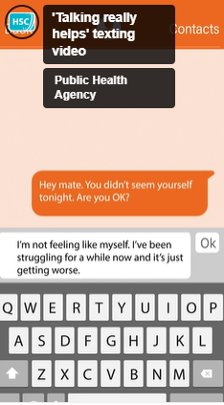 | If you are worried about someone but aren’t sure how to talk to them, you can call Lifeline for advice on 0808 808 8000.  Link:  Learn more at lifelinehelpline.info
Signs to call Lifeline video  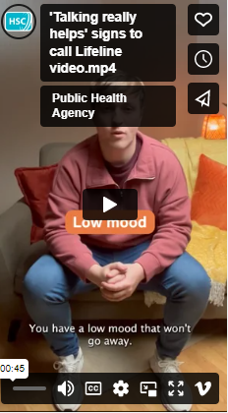 | Do you spot some of these signs in yourself? Talking is the first step in starting to feel better. You can talk to one of Lifeline’s qualified counsellors for free, 24/7.  Link:  Call Lifeline on 0808 808 8000 or visit lifelinehelpline.info to learn more.
Signs you may need to call Lifeline animation  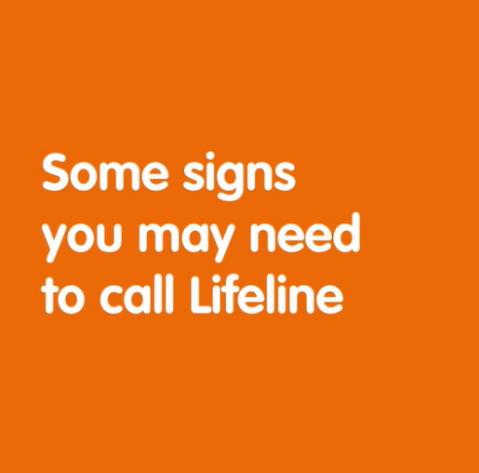 | If you spot these signs in yourself or someone you know, talk to Lifeline. Qualified counsellors are available for free, 24/7. When you start talking, you can start feeling better.  Link:  Call Lifeline on 0808 808 8000 or visit lifelinehelpline.info to learn more.
I can barely cope static  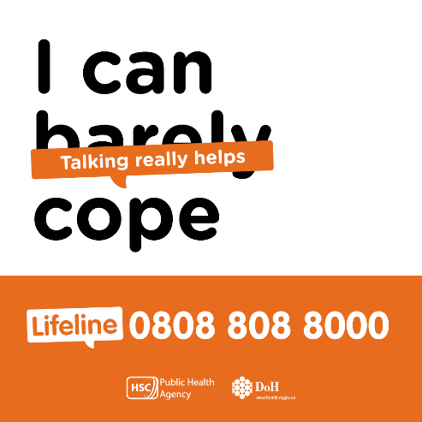 | When you start talking, you can start feeling better. You can talk to Lifeline if you're struggling, or are worried about someone else. Qualified counsellors are available 24 hours a day, 7 days a week.  Link:  Call Lifeline on 0808 808 8000 or visit lifelinehelpline.info to learn more.
I’m not feeling okay static  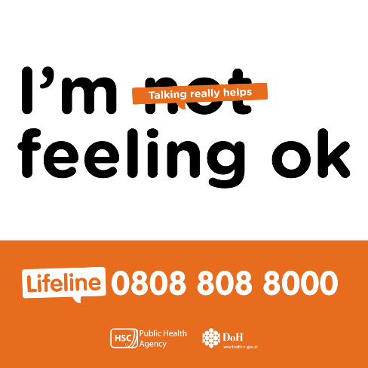 | When you start talking, you can start feeling better. You can talk to Lifeline if you're struggling, or are worried about someone else. Qualified counsellors are available 24 hours a day, 7 days a week.  Link:  Call Lifeline on 0808 808 8000 or visit lifelinehelpline.info to learn more.
I’m not fine static  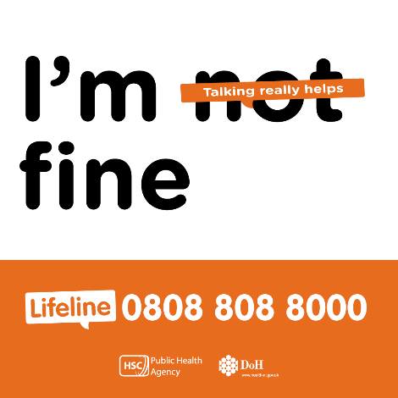 | When you start talking, you can start feeling better. You can talk to Lifeline if you're struggling, or are worried about someone else. Qualified counsellors are available 24 hours a day, 7 days a week.  Link:  Call Lifeline on 0808 808 8000 or visit lifelinehelpline.info to learn more.

