****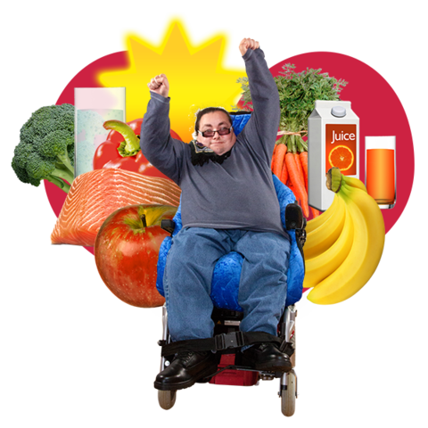****

**Our plan for the**

**next 5 years from**

**2025 to 2030**

# This is not our final plan. We want to know what people think of it first.

**What is this plan about?**

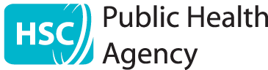

We are called the **Public Health Agency**.



We work to make sure

**everyone** in Northern Ireland

can be healthy and have a good life.



At the moment, this is not always happening.

For example, some people are less healthy than others.



Some good work has been done to change this. But there is much more to do.

This plan is about the things

we will work on in the next 5 years.

There are other big plans that we need to think about as well.

For example, some plans about health called:

* Health and Wellbeing 2026: Delivering Together
* Making Life Better

We are asking lots of people what they think before we make this final plan.

**What will we work on?**

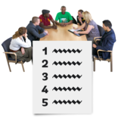

There are **5** main things that we want to happen.

We will work on these things

in the next 5 years.

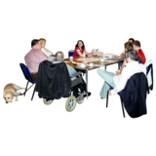We will work with lots of other people and groups to do this.

For example, people who get healthcare and carers.



We will check how our work is going and what needs to change.

We will use good information to help us know how we are doing.



Now you can find out about

the 5 things and how we will

make them happen.

1. **Everyone is healthy and kept safe from illnesses that spread**

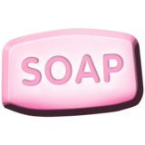

Things we will work on:

* Helping everyone to be healthy and safe from illnesses that spread.

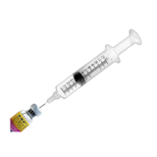

* Stopping children and adults from getting ill.  
    
  For example, by making sure they get injections to stop them getting some illnesses.

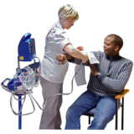

* Finding health problems early on.

For example, by making sure people can have tests to check their health.

And helping more people know about the tests they can have.



* Making sure we can act straight away

if something big happens.

For example, if lots of people get ill with the same thing at once.

1. **All children and young people have the best start in life**

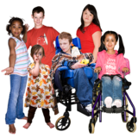

Things we will work on:

* Helping all children and young people to be healthy and happy.

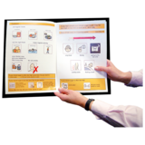

This means having good healthcare and information for all children and young people and their families and carers.

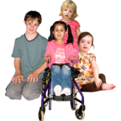

* Helping children and young people early on, while they are young.

This will help them have a better life later on.



* Good tests to check that pregnant mothers and babies are healthy.

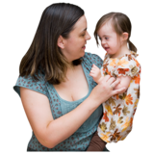Things we will work on:

* Better support for parents and carers to give their children the best start in life.



* Stopping children and young people from getting ill.

For example, by making sure they get injections to stop them getting some illnesses.



* Helping schools and nurseries to be healthy and safe from illnesses that spread.

1. **Everyone can have a long and healthy life**

Things we will work on:



* Helping people look after their health.

For example, by giving people better information about how to be healthy.

And doing more to help people be healthy. For example, to stop smoking, keep active and look after their bodies.



* Finding out any health problems early on.

For example, by making sure people can have tests to check their health.

And helping more people know about

the tests they can have.

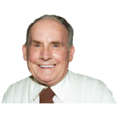

* Helping people feel happy and well so they don’t have mental health problems.

1. **All older people have a healthy and good life**

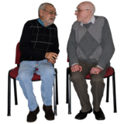Things we will work on:

* Helping older people have a better and healthier life.

For example, there may be better ways to help older people meet new friends or look after their health at home.



* Making sure older people

get the right mental healthcare if they need it.

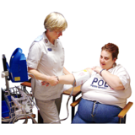

* Making sure older people get the right injections and tests to check their health

and stop them from getting ill.

**5. We work in the best way**

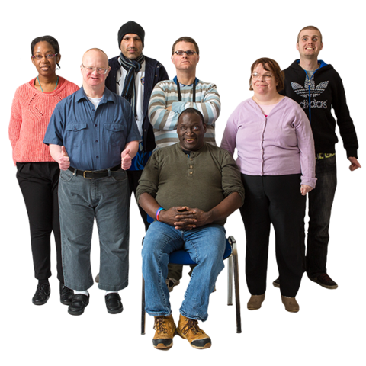Things we will work on:

* Having enough staff to do our work.
* Making sure staff have the right skills.
* Giving our staff the support they need at all times.



* Using good information to help us know what to do.

And helping to get new information when we need to.



* Making sure we can act straight away

if something big happens.

For example, if lots of people get ill with the same thing at once.

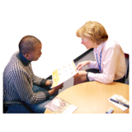

Things we will work on:

* Making sure staff have the right skills to work with everyone in this way.



* Making sure people who get healthcare and carers have a big say about healthcare in Northern Ireland and how to make it better.



* Working in the best way we can and making good decisions.



* Sharing good information and helping people work in the best way.
* Giving the public and other people good information about our work.



**How to tell us what you think**

Please tell us what you think of this plan by **28 February 2025**.



You can send us your ideas by email to: [phacorporateplan@hscni.net](mailto:phacorporateplan@hscni.net)

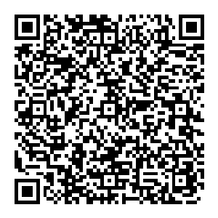

Or scan the QR code to go to the website:

<https://consultations2.nidirect.gov.uk/hsc/pha-corporate-plan-2025-2030-public-consultation>



Thank you!