Purpose
- All staff involved in immunisation have a responsibility to ensure that vaccines are handled and stored appropriately.
- This is to reduce the risk of compromising the quality, efficiency, and safety of the vaccine programme and to improve the service for patients.
- There should be a nominated person (Vaccine Controller) in each area, where vaccines are stored, who is trained.
- Every person involved in storing and handling vaccines should either attend face-to-face training or complete e-learning on cold chain management.
- The PHA has permission from NHS England to share the e-Learning resources for Vaccine Handling and Storage training.
- Please follow the steps in this guide to register for an account to access the resources.
- The registration process should take no longer than 5 minutes, and the e-learning 30 minutes.
Step 1: Visit the NHS England e-Learning website via the link: https://portal.e-lfh.org.uk/
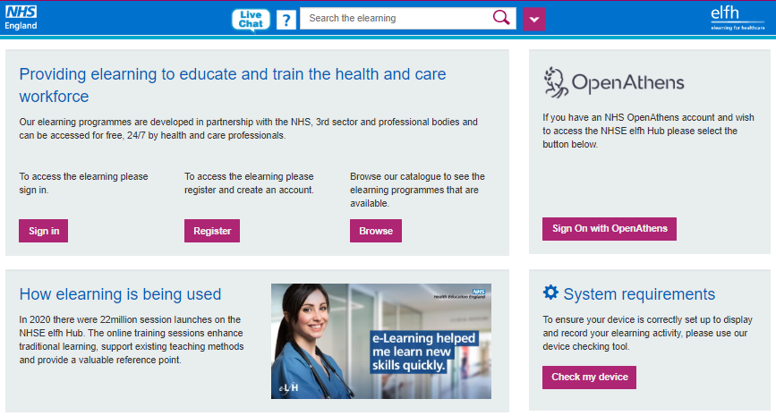

Select “Sign-In” and then “Register for an account.”
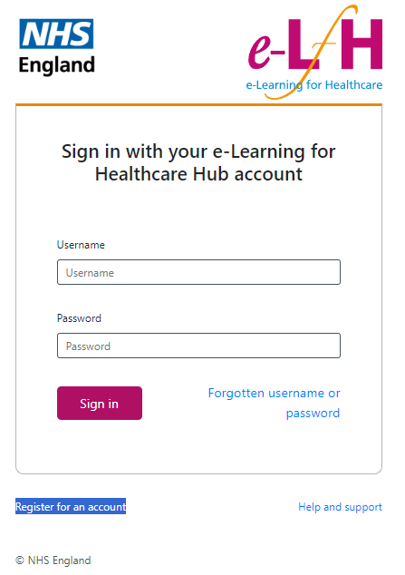
Step 2: Complete Registration
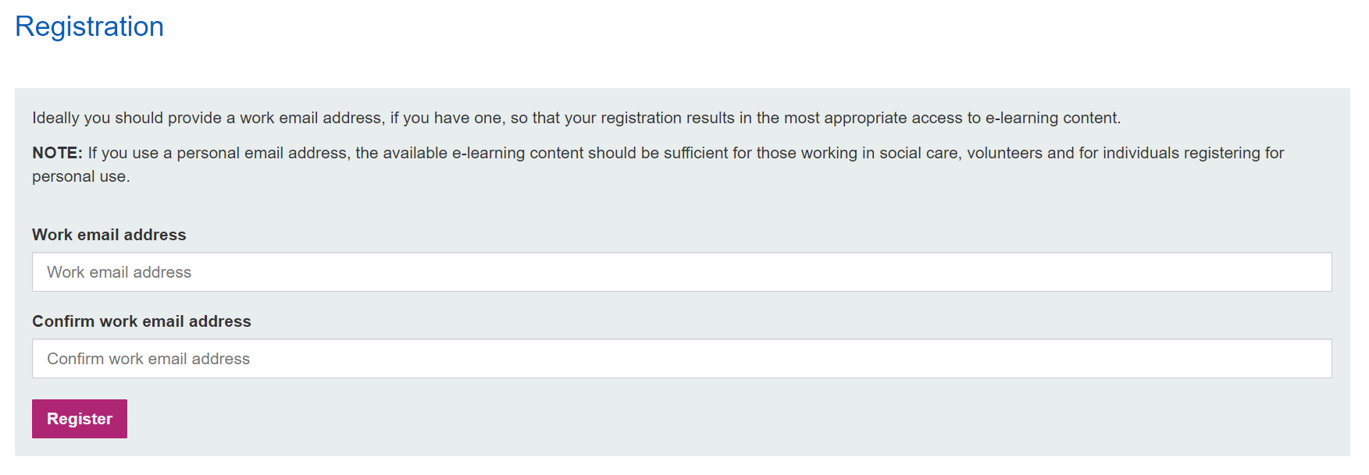
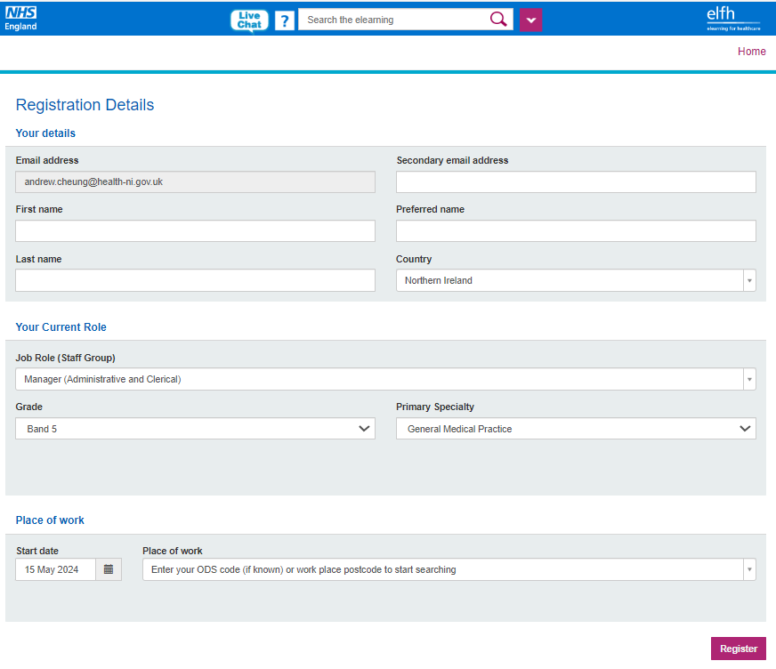

Complete form as appropriate.
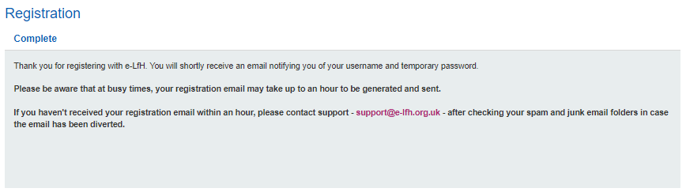

Once completed the above notification will appear and a confirmation email will be sent to your registered email address. The email will contain your username and confirmation hyperlink, please select link to continue with password set up.

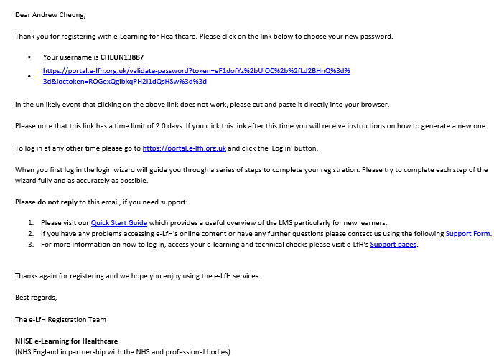

Once password has been set up, continue with password recovery security questions. When completed your account is set up and ready.
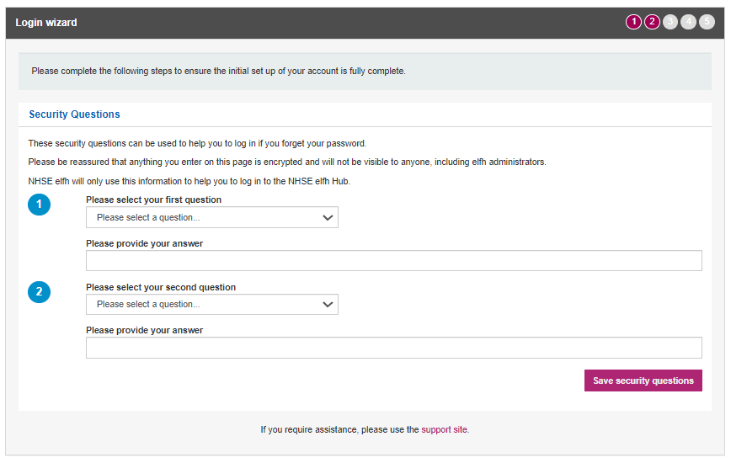

Step 3: Searching for the Immunisation Course
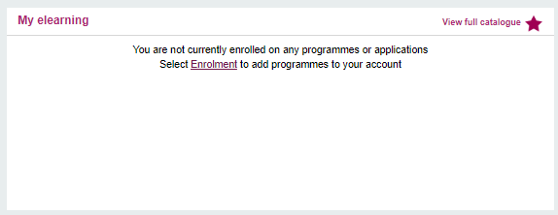

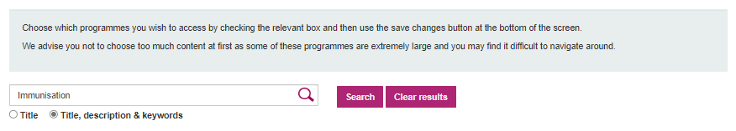
When logged in, follow the onscreen instructions to select “Enrolment.”

Search for “Immunisation” to add onto your My elearning.
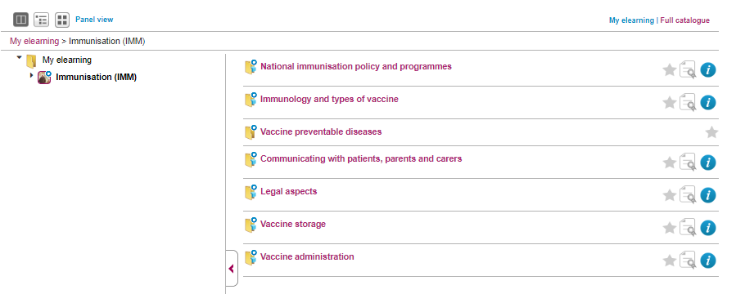

Select the relevant course “Vaccine storage.”
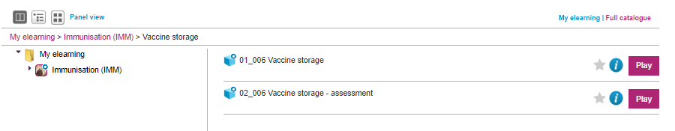

Select “Play” to start training module.

Step 4: Complete the e-learning module

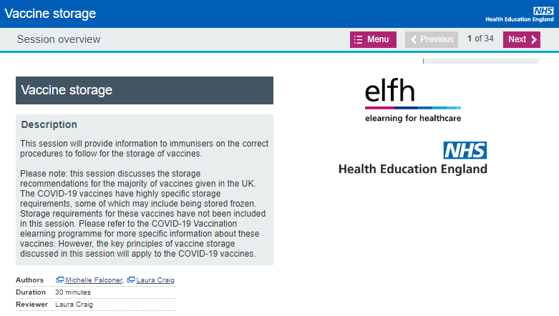

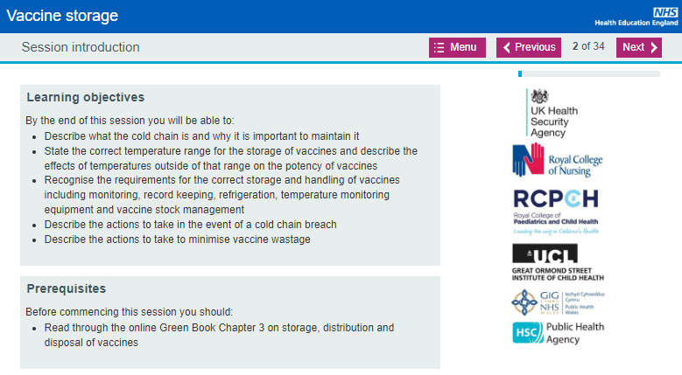

Once the e-Learning is complete, complete the assessment.

Thank you.

If you have any questions or queries, please contact: pha.immunisation@hscni.net

